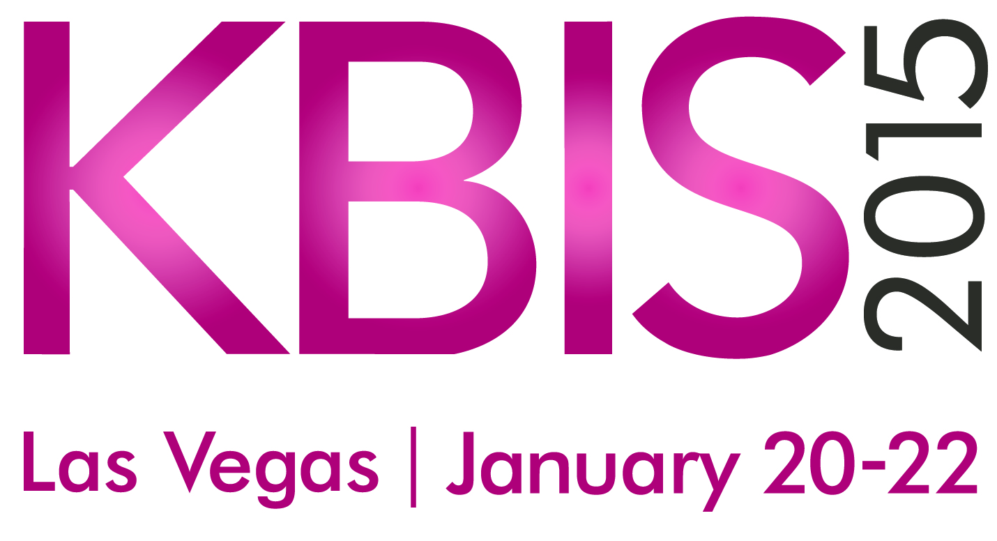

**The Kitchen and Bath Industry Show (KBIS)**

**Dates:** Jan. 20-22, 2015

**Location:** Las Vegas Convention Center (North Hall)

**Exhibit Floor Hours:**

Tuesday, Jan. 20, 2015: 9:00am – 5:00pm

Wednesday, Jan. 21, 2015: 9:00am – 5:00pm

Thursday, Jan. 22, 2015: 9:00am – 5:00pm

**Website:** [www.kbis.com](http://www.kbis.com)

**Show Owner/Producer:**

KBIS is owned by the National Kitchen and Bath Association (NKBA) and produced by Emerald Expositions.

**About KBIS:**KBIS, in conjunction with the National Kitchen and Bath Association (NKBA) is an inspiring, interactive platform that showcases the latest industry products, trends and technologies. At KBIS, the best and brightest assemble to spot trends, experience product introductions and find the practical solutions and valuable connections that will take them into the future KBIS is the voice of the kitchen and bath industry and has been for 50 years.

**Exhibit Space:**

KBIS 2015 is expecting nearly 500 exhibitors and a total net square footage of 300,000.

**Featured Events and Education:**

At KBIS 2015, the NKBA University will be represented in two learning programs: Voices from the Industry (VFTI) sessions, including two VFTI Featured Speakers, and 11 NKBA University courses. The program is intended to provide professional development opportunities for a variety of KBIS attendees. Over 90 VFTI sessions are being offered at KBIS 2015.

Special Events:

* NKBA Design Competition Awards – Monday Jan. 19, 2015 at Tryst Nightclub at the Wynn
* The Party – Monday Jan. 19, 2015 at Tryst Nightclub at the Wynn
* The Bash – Wednesday Jan. 21, 2015 at XS Nightclub at Encore

**Social Media:**

Facebook: [www.facebook.com/KitchenBathIndustryShow](http://www.facebook.com/KitchenBathIndustryShow)

Twitter: <https://twitter.com/kbis2015>

**Press Contact:**

Kristen Jenkins

White Good

717-396-0200

[kbispr@whitegood.com](mailto:kbispr@whitegood.com)